**Quantitative Evidence of Discrimination in Treatment of Minority Groups**

**Introduction**

This report is intended to illustrate the use of ideas in rapid and efficient use of information. The intent is to accelerate organization and determination of ideas in the formulation of new knowledge.

Numerous authors have reported observations of medical discrimination against minorities -- ethnic, racial, socioeconomic, or sexual orientation. To explore the possibility that such observations could be converted to evidence, the scholarly literature dealing with disparities, entered into PubMed during the period 1990-July 2015, were retrieved and analyzed. Ideas involving health disparities supply the following information:

1. A barrier to recognition and/or treatment of a disease was observed by a trained specialist.
2. The frequency of occurrence of that idea is an indicator of potential importance.
3. The relative occurrence of the idea in minority subgroups may indicate a difference in access to or receipt of medical care.

A text analysis approach (Weiner 1979) was introduced to operationalize and formalize Bloom’s (Bloom 1956) taxonomy of learning. That analytic approach focused on the ideas expressed by authors in acquiring and using information.(Weiner 2011) An idea was defined as the combination (pairs, trios, etc.) of informative terms contained within a sentence.(Chen 1988, Hoffman, 1980, Weiner 1979) This operational definition was based on the structure of the simple sentence consisting of a subject, verb, and object. The subject and object constituted a thought or an idea expressed by the author in conveying information.

Historically, linguists employed frequency of use of a key term as a measure in assessing importance in communication. Those frequently used informative terms (i.e., nouns, adjectives, or gerunds) were considered of greater importance in determining meaning. The premise was that subject experts would tend to employ favored terms in describing their subject. (Malogolowkin 1989, Piniewski-Bond 2001, Weiner 1984)

As with key terms and their interpretation, frequency of occurrence of ideas was considered to be an indicator of importance. In addition to presenting simple pairs of terms, authors may tend to use a specific pair as a bridge to more complex ideas. This is done by including additional informative terms within the same sentence. In considering health disparities, the additional terms often were descriptors of sexual minorities. As such, terms such as bisexual, gay, lesbian, and transgender could be included with terms such as health disparities and specific treatments. These complex combinations would express thoughts that were both specific and relevant.

The hypothesis of interest is – ***Can idea frequency and/or type be measures of medical discrimination in dealing with patients from sexual orientation minorities?***

**Methods**

The scholarly literature dealing with health disparities were retrieved from PubMed for the period 1990 through July 2015. There were 11,553 documents retrieved. These contained 2,279,032 ideas.

The analytic software performs the following functions:

1. Separates the text into individual sentences using punctuation to recognize endings.
2. Identifies informative terms (nouns, adjectives, or gerunds) using characteristic endings and contextual relationships. The latter captures terms that authors have linked with recognized informative terms. Those terms may have endings different from those usually used in describing the grammatical words of interest. Examples of these contextually captured terms are: health, disparities, gay, lesbian, transgender. The term – bisexual – would be captured using the noun ending.
3. Combine informative terms in pairs within each sentence.
4. Generate idea records consisting of the pair of terms and bibliographic data indicating the involved document, date of publication and the location of the sentence within the document.
5. Store these idea records in excel files for subsequent analytic use.

The resulting idea files may be processed using the functions built into excel files. These include edit functions (sort, copy, select, or delete) and search functions (find and replace). The idea analysis software’s performance across topics yielded a median of 85% (66% - 99%) capture of vocabulary used by the authors. In the disparity subject, the capture of informative terms was 99%. Capture of ideas exceeded 95% across topics and over 99% in analysis of disparity ideas.

Exhibit 1 shows examples of sentences and corresponding ideas illustrating the capture problem. The document is identified by the assigned identification number. Added to that number for organization of references is the year of publication. Correctly identified informative terms are highlighted in red. Missed terms are in blue. The idea set consists of the terms representing the idea, the time period entered into PubMed, the assigned identification number and the number of the sentence containing the idea.

**Exhibit 1. Sentences and Idea Sets Illustrating Determination of Capture Accuracy.**

***For women, having difficulty taking medications openly at home was associated with a substantial decrease in the probability of being on HAART*** (highly active antiretroviral therapy) ***in the adjusted model (0.59, 95% CI 0.47-0.70 vs. 0.78, 95% CI 0.74-0.83), whereas no significant differences were observed for heterosexual or gay/bisexual men.*** ***(16536681 – 2006)*** (Sayles 2006)

|  |  |  |  |  |
| --- | --- | --- | --- | --- |
| bisexual | Gay | 2005-2009 | 16536681 | 7 |
| bisexual | heterosexual | 2005-2009 | 16536681 | 7 |
| bisexual | Sexual | 2005-2009 | 16536681 | 7 |
| bisexual | Women | 2005-2009 | 16536681 | 7 |

***We also investigated the possible role of HIV infection among gay men and higher rates of psychological distress among lesbians, gay men, and bisexually and homosexually experienced heterosexual individuals in generating these health disparities. (17463371 – 2007)*** (Cochrane 2007)

|  |  |  |  |  |
| --- | --- | --- | --- | --- |
| bisexual | disparities | 2005-2009 | 17463371 | 2 |
| bisexual | Distress | 2005-2009 | 17463371 | 2 |
| bisexual | Gay | 2005-2009 | 17463371 | 2 |
| bisexual | Health | 2005-2009 | 17463371 | 2 |
| bisexual | heterosexual | 2005-2009 | 17463371 | 2 |
| bisexual | Hiv | 2005-2009 | 17463371 | 2 |
| bisexual | infection | 2005-2009 | 17463371 | 2 |
| bisexual | Lesbian | 2005-2009 | 17463371 | 2 |
| bisexual | men | 2005-2009 | 17463371 | 2 |
| bisexual | psychological | 2005-2009 | 17463371 | 2 |
| bisexual | Sexual | 2005-2009 | 17463371 | 2 |

**Results**

The disparity ideas were divided into dimensions or themes based on the meaning of the terms linked with the central term – disparity or disparities. General dimensions would be:

1. Personal factors – those terms describing attributes of the individual studied.
2. Environmental factors – those terms describing attributes of the environment in which the study subject resides.
3. Subject factors – those terms describing attributes of the subject studied.
4. Intervention factors – those terms describing different treatments intended to change the relationship between dimensional factors.
5. Outcome factors – those terms describing the type and degree of change associated with the intervention.
6. Methods – those procedures employed in the capture and performance of the factors in the other dimensions.

In assessing differences between health disparities in the general population versus the minority groups engaged in different sexual orientations, one possible indicator could be the diseases involved in the disparity. Table 1 shows diseases and the frequency of ideas involving each in the general and sexual minority groups reported in 2014 and through July 2015. The central idea linked to each of the terms shown in Tables 1 -7 was disparity & race. Disparity included the singular and plural terms. Race included African, Asian, Black, Caucasian, Hispanic, Latino, and White. LGBT minorities included Lesbian, Gay, Bisexual, and Transgender.

The majority of the diseases were not an issue in the LGBT minorities. Those that were, included – arthritis (1), asthma (13), cancer (47), diabetes (5), and immunodeficiencies (5). These ideas were few compared with the frequencies in the general population.

Table 2 shows the frequencies of ideas dealing with infection. Four of the ideas were absent in the LGBT group while epidemic, hepatitis, and infection were reported. The infectious terms were frequently observed in the general population.

Table 3 shows the occurrence of psychologically related ideas in the two groups. Bipolar was the only one missing from the LGBT groups. However, the frequencies of occurrence in the general population were far greater than those in the sexual minorities group.

Table 4 shows the frequencies of sexually transmitted diseases. Again, the occurrence of those ideas in the general population far exceeded those in the sexual minorities.

The differential occurrence of diseases in racial minorities as compared with sexual orientation minorities suggests that discrimination in medical treatment is more of a problem in racial subgroups.

Table 5 shows treatments of different types and their occurrence in the two groups. In each, the frequency of occurrence in the racial population was greater than that in the sexual minorities. While frequency is relevant, the types of treatments may be more so. Five of the treatments were in the prevention dimension and four in the psychological dimension. Two were financial and two were in the general subject dimension. While active interventions such as – vaccination, vaccine, prophylaxis, coping and counseling – were present in the sexual minority group, the frequencies of these terms in ideas in the racial minorities were higher.

Table 6 shows the treatments that were reported in ideas involving the racial minorities but not the sexual minority groups. These represent more sophisticated treatments suggesting that the barriers to health care may be different in the racial groups compared to the sexual minorities.

Table 7 supports the possibility of differences in disparities by considering the psychological treatments and frequency of ideas.

The idea – disparity and race -- in the 2014-15 documents yielded a total of 14516 ideas of which 8% or 1132 included disparity or disparities as part of the specific combination. Interestingly, 70% of the ideas making up the complete description of race and health disparities were included in the disparity subset. As such, a relevant question is -- ***How much critical information is lost if the focus is on the disparity involved ideas?*** Figure 1 shows the ideas, classified into dimensions for the disparity-race set as well as the expanded document-race set. The ideas in the latter set come from sentences in the same documents. The latter are shown in red.

The ideas from the disparity-race set represented all of the dimensions considered by authors of the literature containing ideas involving the two informative terms. The terms in that set tended to be more general than the ones from adjacent sentences. This is seen when considering the diseases from the two sets of ideas. Those from the document were more specific with terms such as AIDS, asthma, cancer, obesity and stroke. The ethnic ideas added from the document also were more specific (e.g., Hispanic and Indian). The socioeconomic set included education and immigrant as specific links while treatment ideas added Medicare and Medicaid along with sigmoidoscopy.

**Figure 1. Ideas involving Disparity and Race from the 2014-15 Literature Plus Ideas from Other Sentences in the Same Documents (in red).**

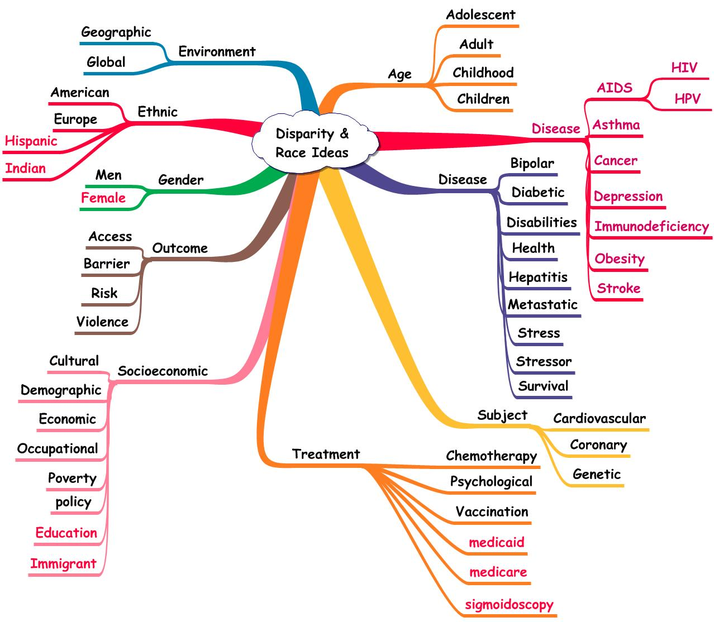

**Discussion**

The intent of this report was to show results from the use of algorithms in Excel that provide descriptions of a new topic (health disparities). More complete demonstrations of the analytic process are available (e.g., eBook at <http://researchdisaster.com>). The algorithms are typical database edit functions and include sorting, copying, replacing, and arithmetic operations (e.g., counting and subtotaling). The availability of these functions aids in transforming a tedious manual process into a rapidly executed and quality-controlled one. In a sense, critical thinking can be transformed from quoting past authors to one of considering the world’s view of the ideas composing a topic. Organization of those ideas can result in new descriptions.

The process applied to health disparities required the processing of approximately 2.2 million ideas. Preliminary organizations suggested the possibility that discrimination of medical care in terms of access and treatment might be different in different subgroups of the population. Specific ones included – age, ethnicity, gender, race, socioeconomic groups and minorities identified by sexual orientation. Comparisons of the more general subgroups with those of sexual orientation showed that disease occurrence (as determined by ideas) was comparable to expectations based on the proportion of sexual orientation subgroups in the population. That is, the LGBT minorities experienced illness but at about the frequency of their group in the population.

Treatments showed a different situation with procedures representing first line or access issues to be problems experienced by the sexual minorities while more sophisticated forms of treatment were problems experienced by the general minorities. As such, access and treatment requiring surgery or advanced psychological care were available to sexual minorities with fewer problems than those experienced by minorities of a more general nature. This hypothesis needs further study.

**Conclusions**

This analysis of the ideas presented by author-specialists dealing with health disparities covered over 11 thousand articles and the time period 1990 through July 2015. Ideas, captured using text analytic software, provided a way to deal with subjects irrespective of the expertise of the analyst. This contrasts with other qualitative approaches that require theme development by the analyst. As such, those analyses may be more opinion-based than evidence-based.

Literature Analysis has been an integral part of knowledge generation and utilization. When performed using manual methods, the results could be considered as summary opinions rather than evidence. This leads to a paradox resolved in clinical trial research by studying interventions that describe the situation in a precise manner as well as establishing ways to minimizing the adverse effects. While that solution has merit in clinical trial research, there are many disciplines that focus on establishing a more complete description of the phenomenon. Interventional studies are not employed. In that situation, observation by a trained specialist is of value as a relevant piece of evidence.

Putting these individual pieces together could be considered to be evidence supporting a new description of the topic as well as hypotheses suitable for further testing. The Idea Analysis approach is a way to organize millions of ideas presented by world’s specialists. The result is a transparent and formalized path to critical thinking. By employing algorithms intended to organize and clarify the individual data points (observational evidence), students can duplicate the creative paths developed by specialists. Accelerating management of large volumes of information is a necessity in a world of search engines delivering millions of documents and websites. In a similar fashion, computer-supported algorithms make the processing feasible.

The idea analysis approach also has the advantage of being quantitative providing evidence that is more accurate and objective. If so, the data suggest that medical treatment discrimination is present, as has been claimed by numerous authors through time. The ideas also suggest that specific sub-specialties were more involved than others. If this interpretation of the data is correct, a follow-up study determining the disciplines and orientations involved could show resolution of this discrimination issue. If so, comparable approaches might be effective in eliminating disparities realized by more general segments of the population (e.g., racial, ethnic, or socioeconomic subgroups).

**References**

Beehler GF, Horowitz RS, Jackman LW, Piniewski-Bond, J, Weiner JM, Weiner, SA. ***Methods in Knowledge Utilization.*** (2009) XXIV Century Press, West Lafayette IN, <http://amazon.com>

Bloom, B. S.; Engelhart, M. D.; Furst, E. J.; Hill, W. H.; Krathwohl, D. R. (1956). ***Taxonomy of educational objectives: The classification of educational goals.*** Handbook I: Cognitive domain. New York: David McKay Company.

Chen J. ***The Natural Structure of Scientific Knowledge: An Attempt to Map a Knowledge Structure***. Journal of Information Science 1988;14:131-139.

[Cochran SD](http://www.ncbi.nlm.nih.gov/pubmed/?term=Cochran%20SD%5BAuthor%5D&cauthor=true&cauthor_uid=17463371)1, [Mays VM](http://www.ncbi.nlm.nih.gov/pubmed/?term=Mays%20VM%5BAuthor%5D&cauthor=true&cauthor_uid=17463371). ***Physical health complaints among lesbians, gay men, and bisexual and homosexually experienced heterosexual individuals: results from the California Quality of Life Survey.*** [Am J Public Health.](http://www.ncbi.nlm.nih.gov/pubmed/?term=17463371) 2007 Nov;97(11):2048-55. Epub 2007 Apr 26. (17463371)

Hoffman E. ***Defining Information: An Analysis of the Information Content of Documents.*** Information Processing and Management 1980;16:291-304.

Malogolowkin MH, Horowitz RS, Ortega JA, Siegel SE, Hammond GD and Weiner JM.

***Tracing expert thinking in clinical trial design.*** Comput Biomed Res 22:190‑208, 1989

Piniewski-Bond J, Buck G, Horowitz R, Schuster J, Weed D, Weiner J. ***Comparison of information processing technologies.*** J Am Med Inform Assoc 2001;8:174-184.

[Sayles JN](http://www.ncbi.nlm.nih.gov/pubmed/?term=Sayles%20JN%5BAuthor%5D&cauthor=true&cauthor_uid=16536681)1, [Wong MD](http://www.ncbi.nlm.nih.gov/pubmed/?term=Wong%20MD%5BAuthor%5D&cauthor=true&cauthor_uid=16536681), [Cunningham WE](http://www.ncbi.nlm.nih.gov/pubmed/?term=Cunningham%20WE%5BAuthor%5D&cauthor=true&cauthor_uid=16536681). ***The inability to take medications openly at home: does it help explain gender disparities in HAART use?*** [J Womens Health (Larchmt).](http://www.ncbi.nlm.nih.gov/pubmed/?term=16536681) 2006 Mar;15(2):173-81. (16536681)

Weiner, J.M.: ***Issues in the Design and Evaluation of Medical Trials.*** G.K. Hall & Co., Boston,

1979.

Weiner JM, Stowe SM, Honour RC, and Hammond GD. ***Assessing scientific performance.***

Infor Proc Manage 20:575‑582, 1984

Weiner JM. ***Effective Creativity in the Workplace*** (2011) Lambert Academic Publishers, Germany, <http://amazon.com>

Weiner JM, ***Is There a Difference Between Critical Thinking and Information Literacy?***

Journal of Information Literacy, December 2011. [*Vol 5, No 2 (2011)*](https://ojs.lboro.ac.uk/ojs/index.php/JIL/issue/view/157).

Yamaguchi N, Latinwo L, Horowitz RS, and Weiner JM. ***Quantitatively expressed***

***ideas in lymphoma: Text versus numerical displays.*** Med Inform 12:273‑279,

1987

**Table 1. Comparison of Treatment Ideas in Relevant Subgroups.**

|  |  |  |  |  |  |  |
| --- | --- | --- | --- | --- | --- | --- |
| **Term** | **Disparity** | **Bisexual** | **Gay** | **Lesbian** | **Transgender** | **Sum Minority** |
| ***Total*** | ***6185*** | ***32*** | ***55*** | ***59*** | ***28*** | ***174*** |
| care | 4036 | 17 | 22 | 29 | 25 | 93 |
| prevent | 631 | 5 | 10 | 6 | 1 | 22 |
| psychological | 44 | 0 | 11 | 7 | 0 | 18 |
| nurse | 107 | 2 | 3 | 2 | 0 | 7 |
| psychiatric | 51 | 0 | 4 | 2 | 1 | 7 |
| nutrition | 100 | 2 | 1 | 2 | 0 | 5 |
| vaccination | 153 | 1 | 0 | 3 | 0 | 4 |
| vaccine | 103 | 2 | 0 | 2 | 0 | 4 |
| coping | 13 | 1 | 1 | 1 | 0 | 3 |
| counseling | 37 | 0 | 1 | 2 | 0 | 3 |
| medicaid | 121 | 1 | 1 | 1 | 0 | 3 |
| prophylaxis | 8 | 1 | 1 | 0 | 1 | 3 |
| contraception | 3 | 0 | 0 | 1 | 0 | 1 |
| psychosocial | 0 | 0 | 0 | 1 | 0 | 1 |
| angioplasty | 3 | **0** | **0** | **0** | **0** | **0** |
| antibacterial | 2 | **0** | **0** | **0** | **0** | **0** |
| antidepressant | 21 | **0** | **0** | **0** | **0** | **0** |
| antihypertensive | 9 | **0** | **0** | **0** | **0** | **0** |
| antipsychotic | 4 | **0** | **0** | **0** | **0** | **0** |
| antiretroviral | 28 | **0** | **0** | **0** | **0** | **0** |
| arthroplasty | 25 | **0** | **0** | **0** | **0** | **0** |
| bypass | 11 | **0** | **0** | **0** | **0** | **0** |
| chemotherapy | 28 | **0** | **0** | **0** | **0** | **0** |
| colectomy | 6 | **0** | **0** | **0** | **0** | **0** |
| colonoscopy | 24 | **0** | **0** | **0** | **0** | **0** |
| dialysis | 16 | **0** | **0** | **0** | **0** | **0** |
| endarterectomy | 4 | **0** | **0** | **0** | **0** | **0** |
| hemodialysis | 2 | **0** | **0** | **0** | **0** | **0** |
| hospice | 24 | **0** | **0** | **0** | **0** | **0** |
| hysterectomy | 5 | **0** | **0** | **0** | **0** | **0** |
| immunization | 67 | **0** | **0** | **0** | **0** | **0** |
| medicare | 139 | **0** | **0** | **0** | **0** | **0** |
| nursing | 138 | **0** | **0** | **0** | **0** | **0** |
| nutrient | 11 | **0** | **0** | **0** | **0** | **0** |
| opioid | 19 | **0** | **0** | **0** | **0** | **0** |
| palliative | 22 | **0** | **0** | **0** | **0** | **0** |
| psychiatrist | 6 | **0** | **0** | **0** | **0** | **0** |
| psychotherapy | 8 | **0** | **0** | **0** | **0** | **0** |
| rehabilitation | 42 | **0** | **0** | **0** | **0** | **0** |
| resuscitation | 2 | **0** | **0** | **0** | **0** | **0** |
| sigmoidoscopy | 5 | **0** | **0** | **0** | **0** | **0** |
| telehealth | 7 | **0** | **0** | **0** | **0** | **0** |
| telemedicine | 11 | **0** | **0** | **0** | **0** | **0** |
| transplantation | 89 | **0** | **0** | **0** | **0** | **0** |